Compound Predicate

✅ What Is a Compound Predicate?
# Source: AI Source: Provided by: [Data Path: Persons Table -> ID Column: 1, Name_En Column: Motasem Essam] -> From: [ChatGPT] on [8/4/2025]
A Compound Predicate occurs when one subject performs two or more actions (verbs or verb phrases), joined by a coordinating conjunction like "and," "or," or "but."

🔸 Key Features:
# Source: AI Source: Provided by: [Data Path: Persons Table -> ID Column: 1, Name_En Column: Motasem Essam] -> From: [ChatGPT] on [8/4/2025]
- Shares the same subject.
- Includes two or more verbs (or verb phrases).
- May include shared or individual modifiers, objects, or complements.
- Joined by coordinating conjunctions (e.g., and, but, or).

🔸 Examples:
# Source: AI Source: Provided by: [Data Path: Persons Table -> ID Column: 1, Name_En Column: Motasem Essam] -> From: [ChatGPT] on [8/4/2025]
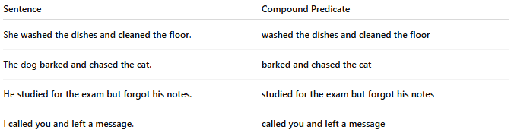
Sentence | Compound Predicate
She washed the dishes and cleaned the floor. | washed the dishes and cleaned the floor
The dog barked and chased the cat. | barked and chased the cat
He studied for the exam but forgot his notes. | studied for the exam but forgot his notes
I called you and left a message. | called you and left a message

🔸 Compare With Simple Predicate:
# Source: AI Source: Provided by: [Data Path: Persons Table -> ID Column: 1, Name_En Column: Motasem Essam] -> From: [ChatGPT] on [8/4/2025]

Type | Example Sentence | Predicate
Simple Predicate | The girl danced. | danced
Compound Predicate | The girl danced and sang. | danced and sang

